## Storyboard (Description and Map)

The evil prince has taken over the castle and is holding the princess hostage. The evil prince plans to force the princess in marriage to become king and ruler of the city. You must find the princess and defeat the evil prince to save the city. Before you face the evil prince, you must grab a few items to prepare for the fight. You will need potion from the alchemy lab to heal health, armor from the cellar to protect your body, the master sword from blacksmith’s forge to defeat the evil prince, lock picking kit from the secret vault to enter the keep, an amulet for your energy from the master bedroom, and a map from the prince’s chambers to navigate the castle.

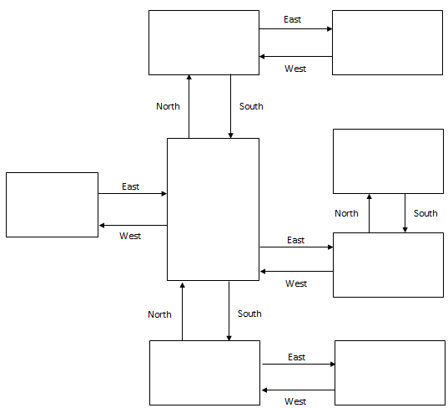

**Prince’s Chamber**

Item: Map

**Blacksmith Forge**

Item: Master Sword

**Alchemy Lab**

Item: Potion

**Secret Vault**

Item: Lock picking kit

**Cellar**

Item: Armor

**Master Bedroom**

Item: Amulet

**Great Chambers**

**Prince’s Keep**

Evil Prince!

## Pseudocode or Flowchart for Code to “Move Between Rooms”

START

Current_room is assigned ‘Great Chambers’ where player starts

LINK rooms together

rooms is assigned {

‘Great Chambers’ : { ‘South’ : ‘Blacksmith Forge’, ‘North’ : ‘Prince Chamber’, ‘West’ : ‘Master Bedroom’, ‘East’ : ‘Secret Vault’},

‘Prince Chamber’ : {‘South’ : ‘Great Chambers’, ‘ East’ : ‘Alchemy Lab’, ‘item’ : ‘Map’},

‘Alchemy Lab’ : {‘West’ : ‘Prince Chamber’, ‘item’ : ‘Potion’},

‘Master Bedroom’ : {‘East’ : ‘Great Chambers’, ‘item’ : ‘Amulet’},

‘Blacksmith Forge’ {‘East’ : ‘Cellar’, ‘North’ : ‘Great Chambers’, ‘item’ : ‘Master Sword’},

‘Cellar’ : {‘West’ : ‘Blacksmith Forge’, ‘item’ : ‘Armor’},

‘Secret Vault’ : {‘West’ : ‘Great Chambers’, ‘North’ : ‘Prince Keep’, ‘item’ : ‘Lock picking kit’}

WHILE

PRINT rooms [current_room]

INPUT user move PRINT as ‘Enter your move’ and save as user_input

Command, direction is assigned user_input.split()

IF command is ‘go’ and direction in rooms[current_room]:

Current_room = rooms[current_room][direction]

ELSE:

PRINT ‘error’

ENDIF

ENDWHILE

END

## Pseudocode or Flowchart for Code to “Get an Item”

START

LINK rooms together with items

rooms is assigned {

‘Great Chambers’ : { ‘description’ : ‘You are in the Great Chambers.’],

‘Prince Chamber’ : { ‘description’ : ‘You are in the Prince Chambers. You see a Map.’, ‘item’ : ‘Map’},

‘Alchemy Lab’ : {‘description’ : ‘You are in the Alchemy Lab. You see a potion.’, ‘item’ : ‘Potion’‘},

‘Master Bedroom’ : {‘description’ : ‘You are in the Master Bedroom. You see an Amulet.’, ‘item’ : ‘Amulet’East’},

‘Blacksmith Forge’ {‘description’ : ‘You are in the Blacksmith Forge. You see the Master Sword’, ‘item’ : ‘Master Sword’},

‘Cellar’ : {‘description’ : ‘You are in the Cellar. You see Armor.’, ‘item’ : ‘Armor’],

‘Secret Vault’ : {‘description’ : ‘You are in the Secret Vault. You see the Evil Prince.’, ‘item’ : ‘Evil Prince’ }

Inventory is assigned [ ]

Current_room = ‘Great Chambers’

WHILE

PRINT (rooms[current_room] ‘decsription’

IF rooms[current_room][‘items’]:

PRINT items in current_room

INPUT user action, save as user_input

Action, item assigned user_input.split()

IF action is ‘get’ and item in rooms[current_room][‘items’]:

Inventory append item

PRINT item ‘retrieved’

Rooms[current_room][‘items’] remove(item)

ELSE:

PRINT ‘error’

ENDIF

ENDWHILE

END